Log Returns
What it is:
- Measures the percentage change of a price from one day to the next using the logarithm.
- Common in finance because log returns are additive over time and approximate continuously compounded returns.
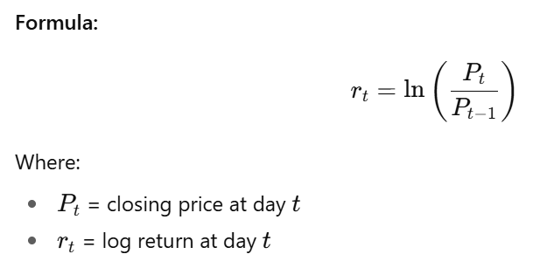
Why it’s useful:
- Captures the daily return while handling compounding naturally.
- Often used as input for volatility and risk models.

Rolling Volatility (10-day)
What it is:
- Measures how much returns fluctuate over a rolling window.
- A higher volatility indicates a more “uncertain” or turbulent market.
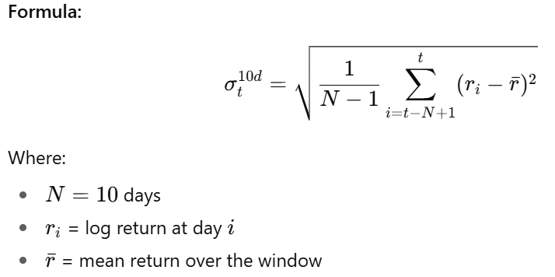
Why it’s useful:
- Detects volatile vs. calm periods.
- Can be used as a regime indicator: high volatility → potential bear/volatile regime.

Momentum (10-day)
What it is:
- Measures the price change over a period (trend strength).
- Momentum strategies assume “winners keep winning.”
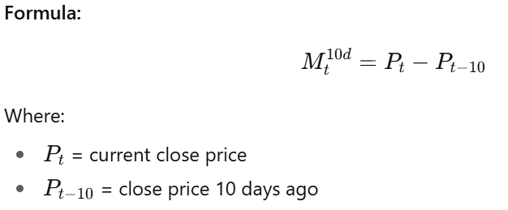
Why it’s useful:
- Positive momentum → price trending up
- Negative momentum → price trending down
- Often used in trend-following strategies.

Moving Averages
a) Simple Moving Average (SMA)
What it is:
- Average of the price over a window.
- Smooths out short-term noise to highlight the trend.
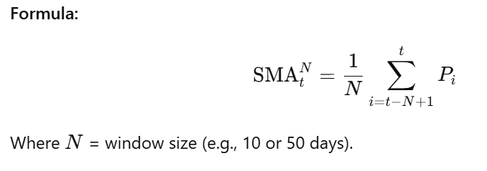
b) Exponential Moving Average (EMA)
What it is:
- Weighted average giving more importance to recent prices.
- Reacts faster to recent market changes than SMA.
Formula (recursive):
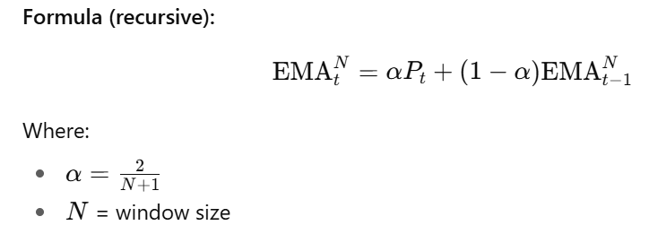
Why MAs are useful:
- Identify trends
- Generate crossover signals (e.g. SMA_10 crossing SMA_50 → trend change)

Drawdown
What it is:
- Measures the percent decline from the previous peak.
- Captures risk of losses over time.
Formula:
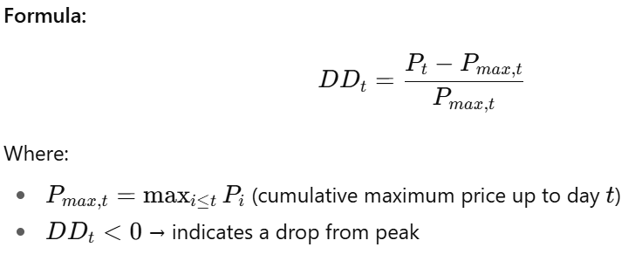
Why it’s useful:
- Tracks downside risk
- Can help define bear vs. bull regimes

